|  |  |  |  |
| --- | --- | --- | --- |
| **Lyng Primary School Knowledge Organiser** | | | |
| **Topic:** | **Ancient Egypt**  **Would you like to live in a desert?** | Year 5  Civilisation and communication | Autumn 2 |

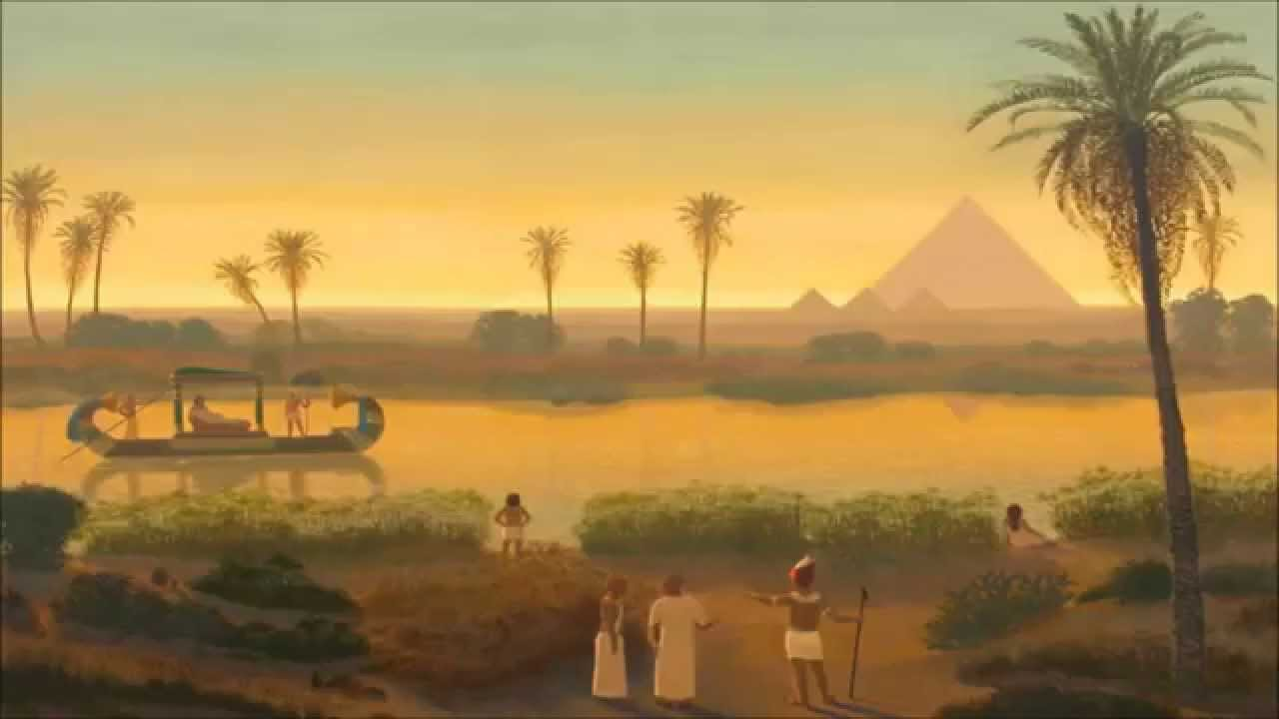

**Background information for parents and teachers.** Egypt is located in the northeast corner of Africa. The Ancient Egyptians lived along the banks of the River Nile in Egypt. It was farmers who first settled there around 5000 BC. Two separate kingdoms (ruled by different kings) developed along the Nile River. The kingdom in Upper Egypt was called the red crown. In about 3200 BC the pharaoh of the north conquered the south and Egypt became united. The pharaoh’s name was King Memphis. In the Greek language, the word Memphis meant “Balance of the Two Lands.” Egypt was one of the greatest civilisations of the past. The monuments and tombs of their pharaohs continue to stand intact today, 4000 year later.



|  |  |
| --- | --- |
| **What Step On and Goldilocks words will I use?** | |
| **Spelling** | **Definition** |
| agriculture | Taking care of the land to grow plants and raise animals for food. |
| arid | Too little rain to support lots of vegetation. |
| barren | A place that does not have much or any plant life. |
| biome | An area with a similar landscape, where similar plants and animals live. |
| desertification | When land turns into a desert. |
| sparse | Only a small number of something over a large area. |
| mesa | A flat topped hill or mountain with steep sides. It has a flat or rocky top that loks like a platform. Mesas are formed by weathering and erosion over a long time. |
| Lines of longitude | invisible vertical lines mapped on the globe to show how far east or west a place is from the Prime/Greenwich Meridian. |
| Irrigation | Water provided to an area of land to grow crops. |
| Prime Meridian | The line of zero degrees longitude that defines all time zones. |

|  |
| --- |
| **Geographical study** |
| * locate the world’s countries, using maps to focus on Europe (including the location of Russia) and North and South America, concentrating on their environmental regions, key physical and human characteristics, countries, and major cities * describe and understand key aspects of: physical geography, including: climate zones, biomes and vegetation belts, rivers, mountains, volcanoes and earthquakes, and the water cycle * describe and understand key aspects of: human geography, including: types of settlement and land use, economic activity including trade links, and the distribution of natural resources including energy, food, minerals and water * use maps, atlases, globes and digital/computer mapping to locate countries and describe features studied |

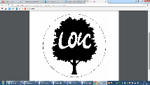

**Significant places**

The Sahara Desert

**Fieldwork Opportunities**

**Virtual fieldtrip – using Google Earth**

**Our Storytelling Approach to enhance engagement**

|  |  |  |
| --- | --- | --- |
| **People:**  Pharaohs  Nobles, priests, viziers, embalmers. | **Place:**  Egypt | **Problem:**  You need to mummify a pharaoh. |

**Key facts and locations**

**Map to be studied**

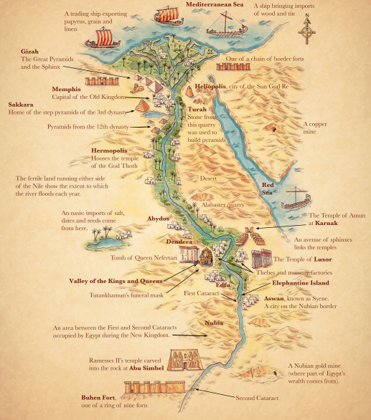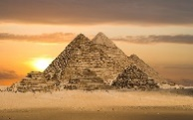

**Giza** is a town just outside the main Egyptian city of Cairo. The pyramids were built in the period of **Egypt** called the Old Kingdom. The Great Pyramid was constructed about 3500 B.C.E, which makes it well more than five thousand years old. In the Old Kingdom, pyramids were built for pharaohs after their death.

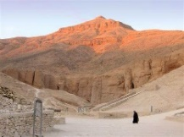

The **Valley of the Kings** contains the tombs, or graves, of dozens of the royal rulers of ancient Egypt. The **valley** lies in the southern half of Egypt, just west of the Nile River. The tombs were built for the pharaohs (**kings**) who ruled from the 1500s BC to the 1000s bc.

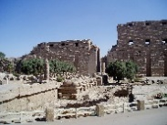

The **importance** of **Karnak** resided in its being the contact point between Amun, the supreme ruler of the universe, and the pharaoh, the supreme ruler on Earth who represented all Egyptian people.

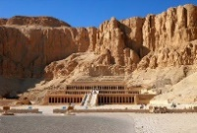

**Agreed Outcome –** Create a leaflet advertising the Sahara Desert for tourists.

**Thebes** was the capital of Egypt during the period of the New Kingdom (c.1570-c.1069 BCE) and became **an important** center of worship of the god Amun (also known **as** Amon or Amen, a combination of the earlier gods Atum and Ra). Its sacred name was P-Amen or Pa-Amen meaning "the abode of Amen".

**Key Questions – sequence of learning**

What is a hot desert biome?

Where are deserts located?

What physical features can be found in a desert ?

How do people use deserts?

Would you like to live in a desert?